## **Project Report: Student Attendance System using Arduino Uno, RFID, and LCD Display**

* **Introduction:**

Attendance tracking in educational institutions is crucial for monitoring student participation and ensuring accountability. Traditional methods of attendance taking are time-consuming and prone to errors. This project aims to develop an automated student attendance system using RFID technology and Arduino Uno microcontroller, providing an efficient and accurate solution to attendance management.

* **Objective:**

The primary objective of this project is to create a cost-effective and user-friendly student attendance system that utilizes RFID tags to identify students and records their attendance in real-time. The system will display the attendance information on an LCD screen for easy monitoring by instructors.

## **Components Used:**

## Arduino Uno microcontroller

## RFID Reader Module

## RFID Tags (for students)

## LCD Display (16x2)

## Breadboard and Jumper Wires

## USB Cable (for Arduino Uno)

## **Connection Setup**

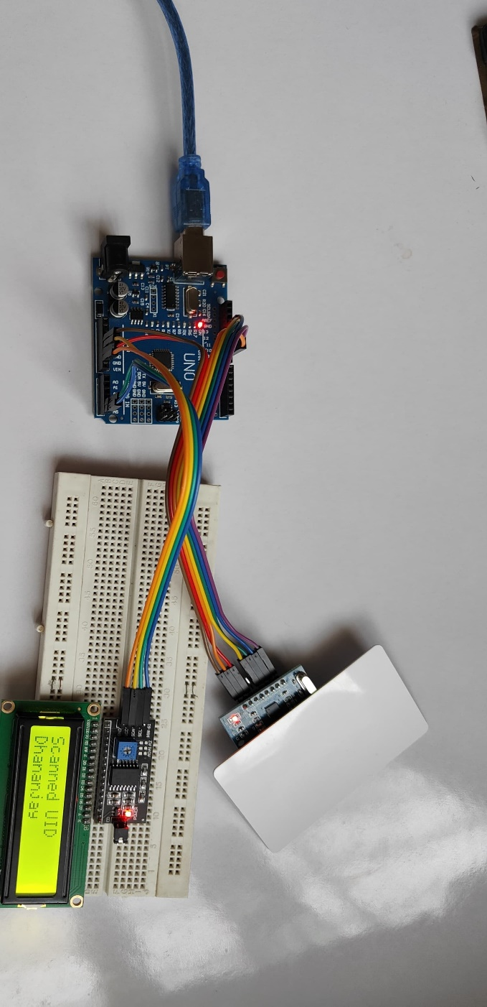

## **Arduino Sketch**

#include <LiquidCrystal_I2C.h>

#include <SPI.h>

#include <MFRC522.h>

#define RST_PIN 9

#define SS_PIN 10

byte readCard[4];

byte a = 0;

LiquidCrystal_I2C lcd(0x27, 16, 2); // Adjust the LCD dimensions as needed

MFRC522 mfrc522(SS_PIN, RST_PIN);

// Define mappings between UID and strings

struct CardMapping {

byte uid[4];

const char* name;

};

CardMapping cardMappings[] = {

{{0xD3, 0xF0, 0x60, 0xF6}, "Dhananjay"},

{{0x93,0x20,0x53,0xc5},"Shubham"} // Updated mapping

// Add more mappings as needed

};

void setup() {

Serial.begin(115200);

lcd.init(); // Initialize the LCD (no need for begin())

lcd.backlight();

while (!Serial);

SPI.begin();

mfrc522.PCD_Init();

delay(4);

mfrc522.PCD_DumpVersionToSerial();

lcd.setCursor(2, 0);

lcd.print("Put your card");

}

void loop() {

if (!mfrc522.PICC_IsNewCardPresent()) {

return;

}

if (!mfrc522.PICC_ReadCardSerial()) {

return;

}

lcd.clear();

lcd.setCursor(0, 0);

lcd.print("Scanned UID");

Serial.print("Scanned PICC's UID: ");

for (uint8_t i = 0; i < 4; i++) {

readCard[i] = mfrc522.uid.uidByte[i];

Serial.print(readCard[i], HEX);

Serial.print(" ");

}

Serial.println();

// Match scanned UID to a name

const char* cardName = "Unknown";

for (size_t i = 0; i < sizeof(cardMappings) / sizeof(cardMappings[0]); i++) {

bool match = true;

for (size_t j = 0; j < 4; j++) {

if (readCard[j] != cardMappings[i].uid[j]) {

match = false;

break;

}

}

if (match) {

cardName = cardMappings[i].name;

break;

}

}

Serial.print("Scanned PICC's Name: ");

Serial.println(cardName);

lcd.setCursor(0, 1);

lcd.print(cardName);

delay(2000); // Display the name for 2 seconds

lcd.clear();

mfrc522.PICC_HaltA();

}

## **Implementation:**

## The implementation of the system involves the following steps:

## **Hardware Setup**: Connect the RFID reader module, LCD display, and Arduino Uno on the breadboard using jumper wires.

## **Software Installation**: Install the necessary libraries for RFID and LCD display in the Arduino IDE.

## **Code Development**: Develop Arduino code to read RFID tag data, display attendance information on the LCD, and manage system operations.

## **Testing**: Test the system by scanning RFID tags and verifying if attendance data is displayed correctly on the LCD.

## **Integration**: Integrate the system components into a single unit ensuring proper functionality and stability.

* **System Operation:**
* Students carry RFID tags with unique identification numbers.
* When a student enters the classroom, they swipe their RFID tag near the RFID reader module.
* The RFID reader reads the tag data and sends it to the Arduino Uno.
* Arduino Uno processes the data, identifies the student, and updates the attendance records.
* The LCD display shows the current attendance status, indicating the number of students present.
* Instructors can monitor attendance in real-time and take necessary actions based on the data displayed.
* **Benefits:**
* Automated attendance tracking reduces manual effort and eliminates errors.
* Real-time attendance monitoring enhances accountability and facilitates timely interventions.
* Cost-effective solution using readily available components.
* Scalable and customizable system adaptable to various educational settings.
* **Future Enhancements:**
* Integration with a database for storing attendance records.
* Incorporation of biometric identification for enhanced security.
* Implementation of wireless communication for remote monitoring and data retrieval.
* Development of a user interface for easier system management and reporting.
* **Conclusion:**

The Student Attendance System developed using Arduino Uno, RFID, and LCD display offers an efficient and reliable solution for attendance management in educational institutions. By automating the attendance tracking process, the system streamlines administrative tasks and provides valuable insights into student engagement. With further enhancements and customization, it can serve as a robust tool for improving educational outcomes and fostering a conducive learning environment.

* **References:**
* Arduino Documentation
* RFID Library for Arduino
* LCD Library for Arduino
* Online tutorials and resources for Arduino projects